**What is agile project management?** Put simply, it's a group of software development methods based on iterative and incremental development. Where traditional [waterfall](https://www.pivotaltracker.com/agile/agile-vs-waterfall) methods aim to map out all the sequential development steps from A to Z, agile instead focuses on first going from A to B, then from B to C. It’s a conceptual framework that promotes incremental, well-planned iterations throughout the development cycle.

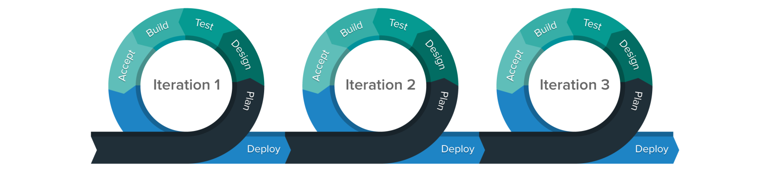

**What are the benefits of agile?**

* **It provides greater transparency.** Everyone—from the stakeholders to the developers, designers, and PMs who do the work—is involved and, therefore, know what’s being worked on. Both the current project status and the road ahead are crystal clear.
* **It makes you more flexible.** Shifting priorities or new business needs? No problem! Inserting and reprioritizing stories in your backlog is instantaneous, allowing you to stay nimble and adjust accordingly.
* **It makes your team more predictable.** Because the work is clearly prioritized and organized in tight sprints (ideally, one or two weeks at a time), new features are shipped frequently and more predictably.
* **It allows you to focus on business values.** The stakeholder (or customer) determines the order in which features are built, which lets the team know what’s most important for the business.
* **It helps you focus on users.** The purpose of user stories is to meet the needs of real users, so that each feature that is designed and developed delivers incremental value.
* **It will increase the quality of your software.** When the work is broken down into manageable units and frequent builds, testing and reviews are more focused. As a result of being able to locate and fix defects more easily and rapidly, you can improve the quality of what you build.

**How does Pivotal Tracker support agile?**

* **It makes your team completely transparent.** Every member of the team can clearly see the work that needs to be completed next, and how the project is progressing.
* **It puts your team in control.** Adding or reprioritizing work happens with the click of a button. Quickly add new stories to your backlog or reprioritize the ones you have by dragging and dropping them into place.
* **It makes your team completely predictable.** But in a good way! Tracker automatically calculates how much work the team can complete in any given iteration based on their past performance, enabling candid conversations about what is truly deliverable.

**Tracker’s simple yet powerful workflow guides the entire team.**

Unlike [other tools](https://www.pivotaltracker.com/agile/tracker-vs-trello) that need to be configured, Tracker is prebuilt to support agile teams with a process that works. With one process for all your teams, members can move from team to team and never get lost.